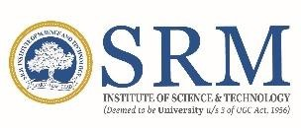

# SRM INSTITUTE OF SCIENCE AND TECHNOLOGY KATTANKULATHUR – 603 203

## BONAFIDE CERTIFICATE

Certified that 18CSP107L project report titled **“DDoS Protection System for Cloud using AWS and Machine Learning”** is the bonafide work of “**SHAURYA SINGH SRINET [RA2111032010006], SHOUNAK CHANDRA [RA2111032010026], CHARVI JAIN [RA2111047010113]”** who carried out the project work under my supervision. Certified further, that to the best of my knowledge the work reported herein does not form any other project report or dissertation based on which a degree or award was conferred on an earlier occasion on this or any other candidate.

|  |  |
| --- | --- |
| **Dr. NAGENDRA PRABHU S.** | **Dr. R. ANNIE UTHRA** |
| **SUPERVISOR** | **Professor and Head of The Department** |
| **Assistant Professor** | DEPARTMENT OF COMPUTATIONAL |
| DEPARTMENT OF COMPUTATIONAL INTELLIGENCE | INTELLIGENCE |

